VISVESVARAYA TECHNOLOGICAL UNIVERSITY
“JnanaSangama”, Belgaum -590014, Karnataka.

LAB REPORT
on
Artificial Intelligence (23CS5PCAIN)
Submitted by
Tamanna Barman (1WA23CS006)
in partial fulfillment for the award of the degree of
BACHELOR OF ENGINEERING
in
COMPUTER SCIENCE AND ENGINEERING

B.M.S. COLLEGE OF ENGINEERING
(Autonomous Institution under VTU)
BENGALURU-560019
Aug-2025 to Dec-2025

B.M.S. College of Engineering,
Bull Temple Road, Bangalore 560019
(Affiliated To Visvesvaraya Technological University, Belgaum)
Department of Computer Science and Engineering

CERTIFICATE
This is to certify that the Lab work entitled “Artificial Intelligence (23CS5PCAIN)” carried out by TAMANNA BARMAN (1WA23CS006), who is bonafide student of B.M.S. College of Engineering. It is in partial fulfillment for the award of Bachelor of Engineering in Computer Science and Engineering of the Visvesvaraya Technological University, Belgaum. The Lab report has been approved as it satisfies the academic requirements in respect of an Artificial Intelligence (23CS5PCAIN) work prescribed for the said degree.

Mamatha M  Associate/Assistant Professor  Department of CSE, BMSCE | Dr. Kavitha Sooda  Professor & HOD  Department of CSE, BMSCE

Index
Sl.  No. | Date | Experiment Title | Page No.
1 | 12-8-2025 | Implement Tic –Tac –Toe Game  Implement vacuum cleaner agent
2 | 19-8-2025 | Implement 8 puzzle problems using Depth First Search (DFS)  Implement Iterative deepening search algorithm
3 | 26-8-2025 | Implement A* search algorithm
4 | 2-9-2025 | Implement Hill Climbing search algorithm to solve N-Queens problem
5 | 9-9-2025 | Simulated Annealing to Solve 8-Queens problem
6 | 16-9-2025 | Create a knowledge base using propositional logic and show that the given query entails the knowledge base or not.
7 | 23-9-2025 | Implement unification in first order logic
8 | 30-09-2025 | Create a knowledge base consisting of first order logic statements and prove the given query using forward reasoning.
9 | 14-10-2025 | Create a knowledge base consisting of first order logic statements and prove the given query using Resolution
10 | 21-10-2025 | Implement Alpha-Beta Pruning.

Github Link: https://github.com/1WA23CS006/ai-lab-programs

Program 1
Implement Tic –Tac –Toe Game
#tic-tac-toe

def display_board(board):
print(f"{board[0]}|{board[1]}|{board[2]}")
print("-------")
print(f"{board[3]}|{board[4]}|{board[5]}")
print("-------")
print(f"{board[6]}|{board[7]}|{board[8]}")

def player(board):
while True:
try:
move = int(input("\nenter move(0 to 8) for P1:\t"))
if 0 <= move <= 8 and board[move] == " ":
board[move] = "X"
break
else:
print("invalid move")
break
except ValueError:
print("Invalid input. Please enter a number between 0 and 8.")
break

def computer(board):
while True:
try:
move = int(input("\nenter move(0 to 8) for P2:\t"))
if 0 <= move <= 8 and board[move] == " ":
board[move] = "O"
break
else:
print("invalid move")
break
except ValueError:
print("Invalid input. Please enter a number between 0 and 8.")
break

def check_win(board, sign):
win_combo = [(0, 1, 2), (3, 4, 5), (6, 7, 8), (0, 3, 6), (1, 4, 7), (2, 5, 8), (0, 4, 8), (2, 4, 6)]
for i in win_combo:
if board[i[0]] == board[i[1]] == board[i[2]] == sign:
return True
return False

def check_tie(board):
for i in range(9):
if board[i] == " ":
return False
return True

board = [" "] * 9

while True:
print("Tic Tac Toe")
while True:
display_board(board)
player(board)
if check_win(board, "X"):
print(" ")
display_board(board)
print("player won")
break
if check_tie(board):
print(" ")
display_board(board)
print("It's a tie")
break

display_board(board)

computer(board)
if check_win(board, "O"):
print(" ")
display_board(board)
print("computer won")
break
if check_tie(board):
print(" ")
display_board(board)
print("It's a tie")
break

ans=input("\n\nsay yes for new round\t")
if ans=="yes":
board = [" "] * 9
else:
break
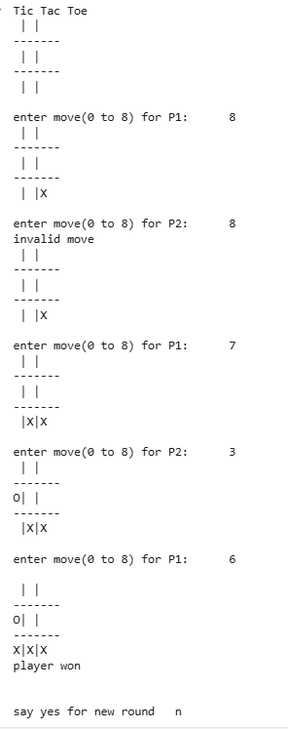
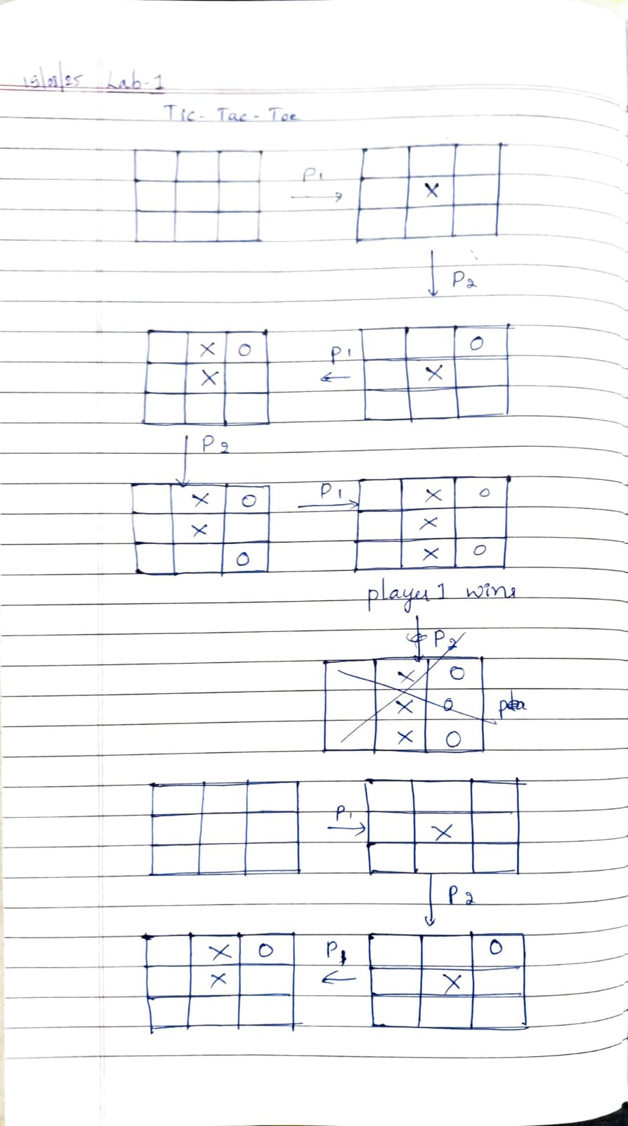
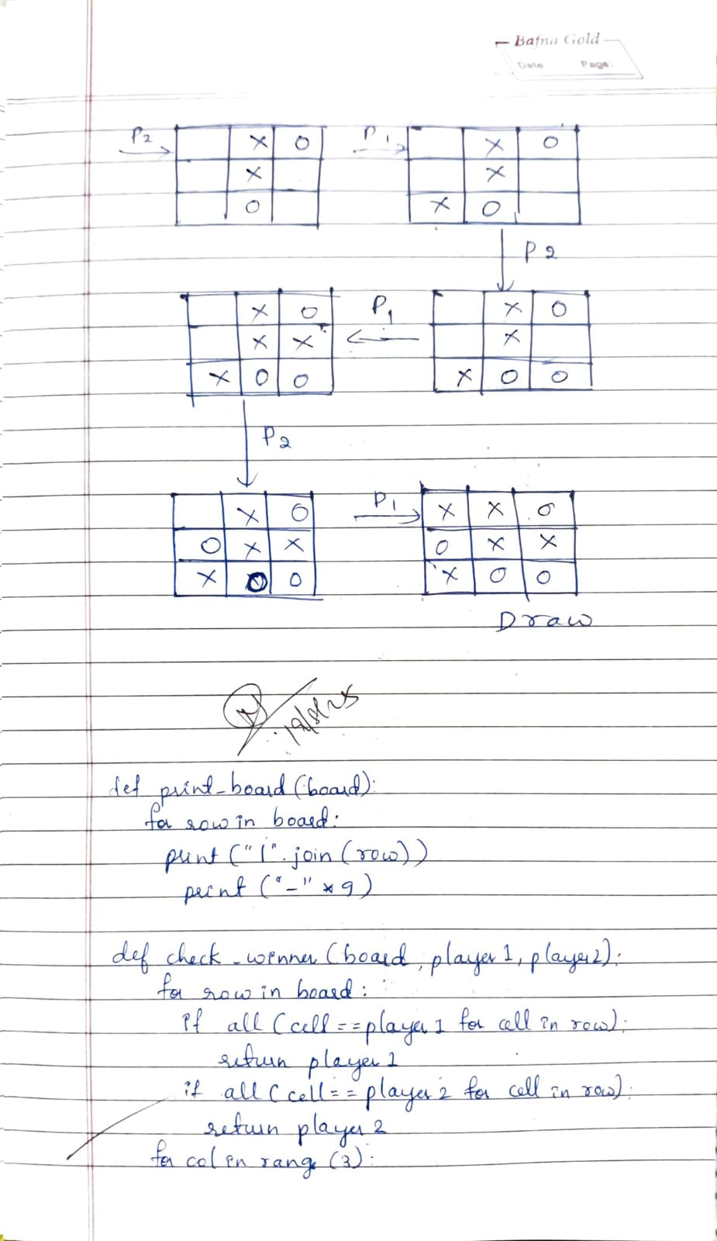
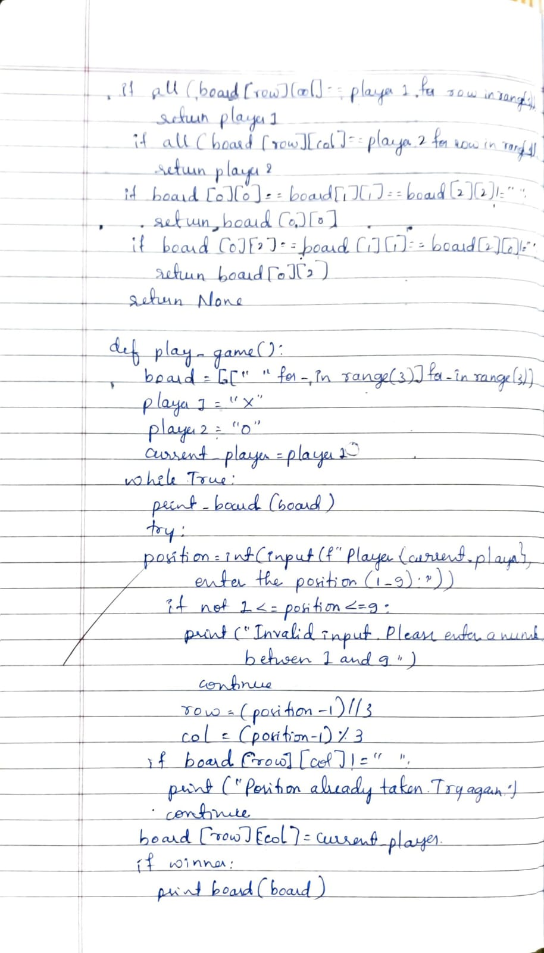
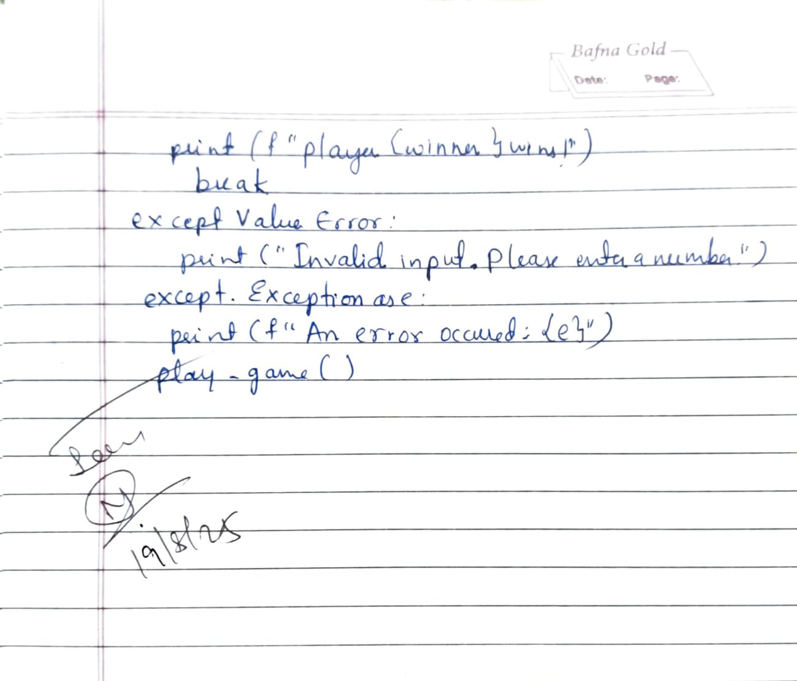
Implement vacuum cleaner agent
#vacuum cleaner
goal_state={"A":"0","B":"0"}
action=0
cost=0
room_state={"A":"0","B":"0"}
location=input("enter the location of vacuum cleaner(either A or B):")
for room in room_state:
action=input("enter the state of "+room+"(0 or 1)")
room_state[room]=action
print("Goal state is:",goal_state)
print("Room state is:",room_state)
if(room_state!=goal_state):
if(location=="A"):
if(room_state["A"]=="1"):
room_state["A"]="0"
cost+=1
print("room A was dirty\nroom A is cleaned\ncost for cleaning room A is 1")
if(room_state==goal_state):
print("Goal is reached")
print("mainainance cost is:",cost)
else:
print("room A is clean\nmoving from A to room B\ncost for moving from A to B is 1")
cost+=1
if(room_state["B"]=="1"):
room_state["B"]="0"
cost+=1
print("room B was dirty\nroom B is cleaned\ncost for cleaning room B is 1")
if(room_state==goal_state):
print("Goal is reached")
print("mainainance cost is:",cost)
else:
if(room_state["B"]=="1"):
room_state["B"]="0"
cost+=1
print("room B was dirty\nroom B is cleaned\ncost for cleaning room B is 1")
if(room_state==goal_state):
print("Goal is reached")
print("mainainance cost is:",cost)
else:
print("room B is clean\nmoving from room A to room B\ncost for moving from A to B is 1")
cost+=1
if(room_state["A"]=="1"):
room_state["A"]="0"
cost+=1
print("room A was dirty\nroom A is cleaned\ncost for cleaning room A is 1")
if(room_state==goal_state):
print("Goal is reached")
print("mainainance cost is:",cost)
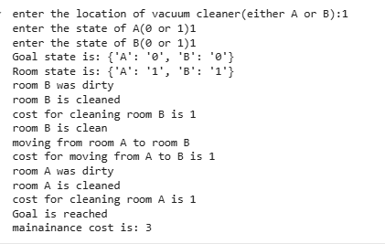
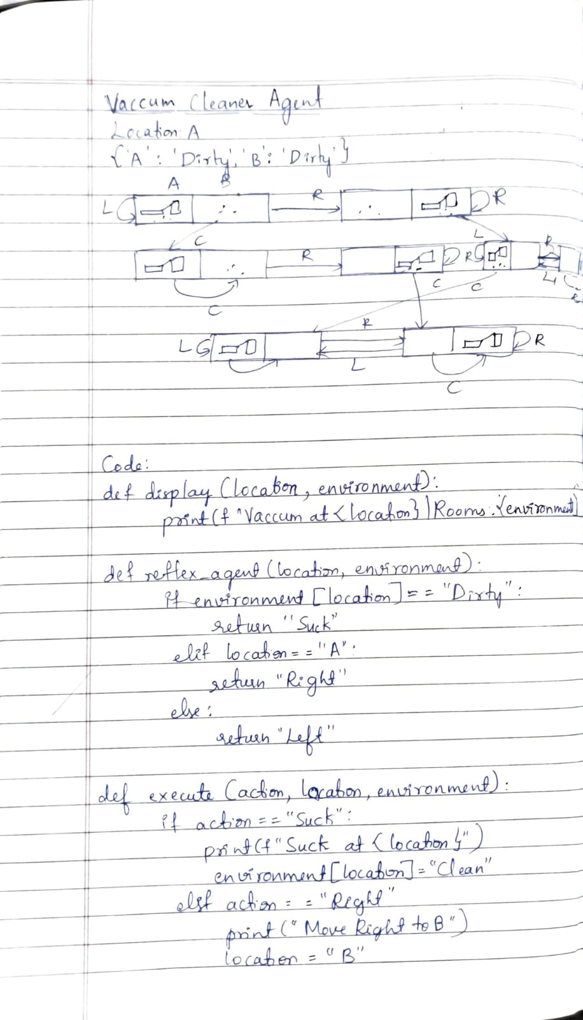
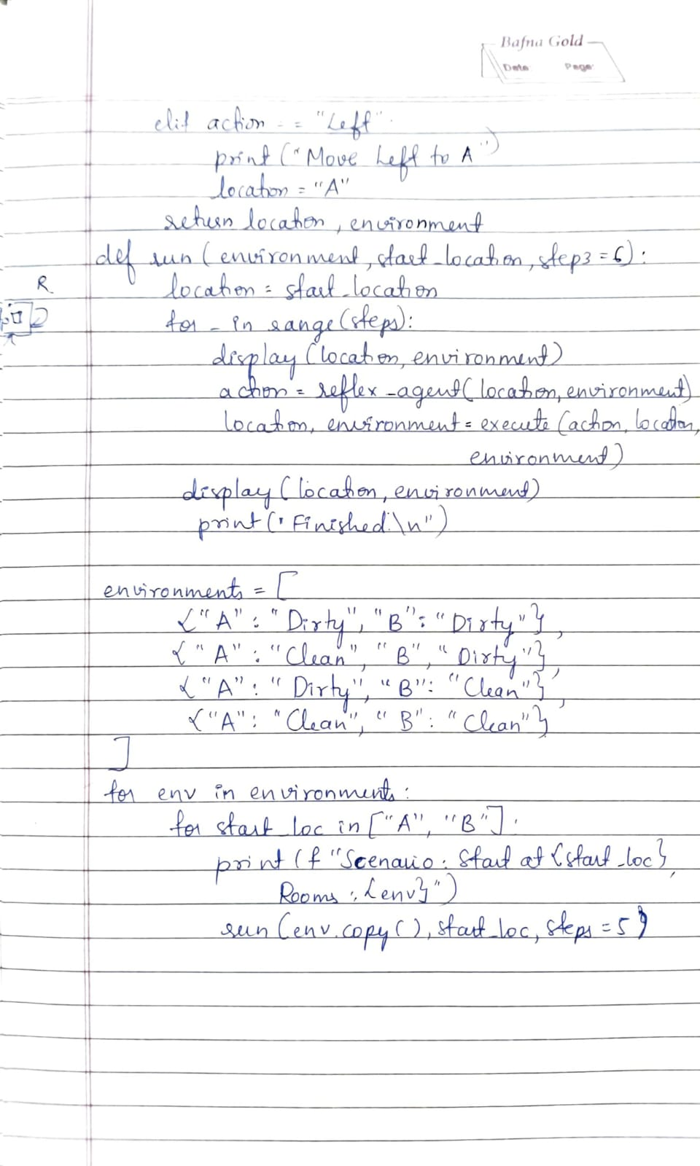

Program 2
Implement 8 puzzle problems using Depth First Search (DFS)
import copy

def get_puzzle(name):
print(f"\nEnter the {name} puzzle (3x3, use -1 for blank):")
puzzle = []
for i in range(3):
row = list(map(int, input(f"Row {i+1} (space-separated 3 numbers): ").split()))
puzzle.append(row)
return puzzle

def move(temp, movement):
for i in range(3):
for j in range(3):
if temp[i][j] == -1:
if movement == "up" and i > 0:
temp[i][j], temp[i-1][j] = temp[i-1][j], temp[i][j]
elif movement == "down" and i < 2:
temp[i][j], temp[i+1][j] = temp[i+1][j], temp[i][j]
elif movement == "left" and j > 0:
temp[i][j], temp[i][j-1] = temp[i][j-1], temp[i][j]
elif movement == "right" and j < 2:
temp[i][j], temp[i][j+1] = temp[i][j+1], temp[i][j]
return temp
return temp

def is_goal(state, goal):
return state == goal

def puzzle_to_tuple(puzzle):
return tuple(tuple(row) for row in puzzle)

def dfs(start, goal, max_depth=50):
stack = [(start, [], [], 0)]
visited = set()

while stack:
current, path, moves, depth = stack.pop()
if puzzle_to_tuple(current) in visited:
continue

visited.add(puzzle_to_tuple(current))

if is_goal(current, goal):
print("\nSolution found!")
for step in path + [current]:
for row in step:
print(row)
print()
print("Moves:", moves)
print("Path cost =", len(moves))
return

if depth >= max_depth:
continue

for move_dir, opposite in [("up","down"), ("left","right"), ("down","up"), ("right","left")]:
if moves and move_dir == {"up":"down", "down":"up", "left":"right", "right":"left"}[moves[-1]]:
continue

new_state = move(copy.deepcopy(current), move_dir)
if new_state != current:
stack.append((new_state, path + [current], moves + [move_dir], depth + 1))

print("No solution found within depth limit.")

start_puzzle = get_puzzle("start")
goal_puzzle = get_puzzle("goal")

print("\n~~~~~~~~~~~~ DFS ~~~~~~~~~~~~")
dfs(start_puzzle, goal_puzzle)
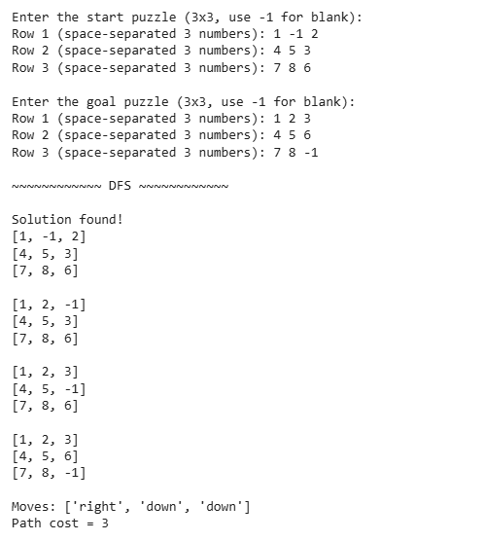
Implement Iterative deepening search algorithm
#8 puzzle problem
import copy

def get_puzzle(name):
print(f"\nEnter the {name} puzzle (3x3, use -1 for blank):")
puzzle = []
for i in range(3):
row = list(map(int, input(f"Row {i+1} (space-separated 3 numbers): ").split()))
puzzle.append(row)
return puzzle

def move(temp, movement):
for i in range(3):
for j in range(3):
if temp[i][j] == -1:
if movement == "up" and i > 0:
temp[i][j], temp[i-1][j] = temp[i-1][j], temp[i][j]
elif movement == "down" and i < 2:
temp[i][j], temp[i+1][j] = temp[i+1][j], temp[i][j]
elif movement == "left" and j > 0:
temp[i][j], temp[i][j-1] = temp[i][j-1], temp[i][j]
elif movement == "right" and j < 2:
temp[i][j], temp[i][j+1] = temp[i][j+1], temp[i][j]
return temp
return temp

def dls(puzzle, depth, limit, last_move, goal):
if puzzle == goal:
return True, [puzzle], []

if depth >= limit:
return False, [], []

for move_dir, opposite in [("up","down"), ("left","right"), ("down","up"), ("right","left")]:
if last_move == opposite:
continue
temp = copy.deepcopy(puzzle)
new_state = move(temp, move_dir)
if new_state != puzzle:
found, path, moves = dls(new_state, depth+1, limit, move_dir, goal)
if found:
return True, [puzzle] + path, [move_dir] + moves
return False, [], []

def ids(start, goal):
for limit in range(1, 50):
print(f"\nTrying depth limit = {limit}")
found, path, moves = dls(start, 0, limit, None, goal)
if found:
print("\nSolution found!")
for step in path:
print(step)
print("Moves:", moves)
print("Path cost =", len(path)-1)
return
print("\nSolution not found within depth limit.")

start_puzzle = get_puzzle("start")
goal_puzzle = get_puzzle("goal")

print("\n~~~~~~~~~~~~ IDDFS ~~~~~~~~~~~~")
ids(start_puzzle, goal_puzzle)
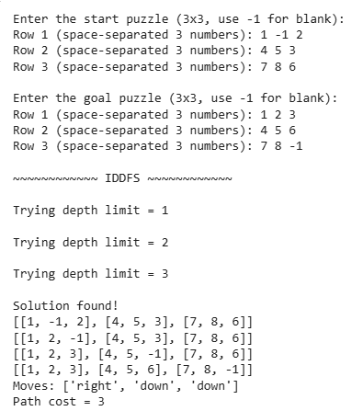
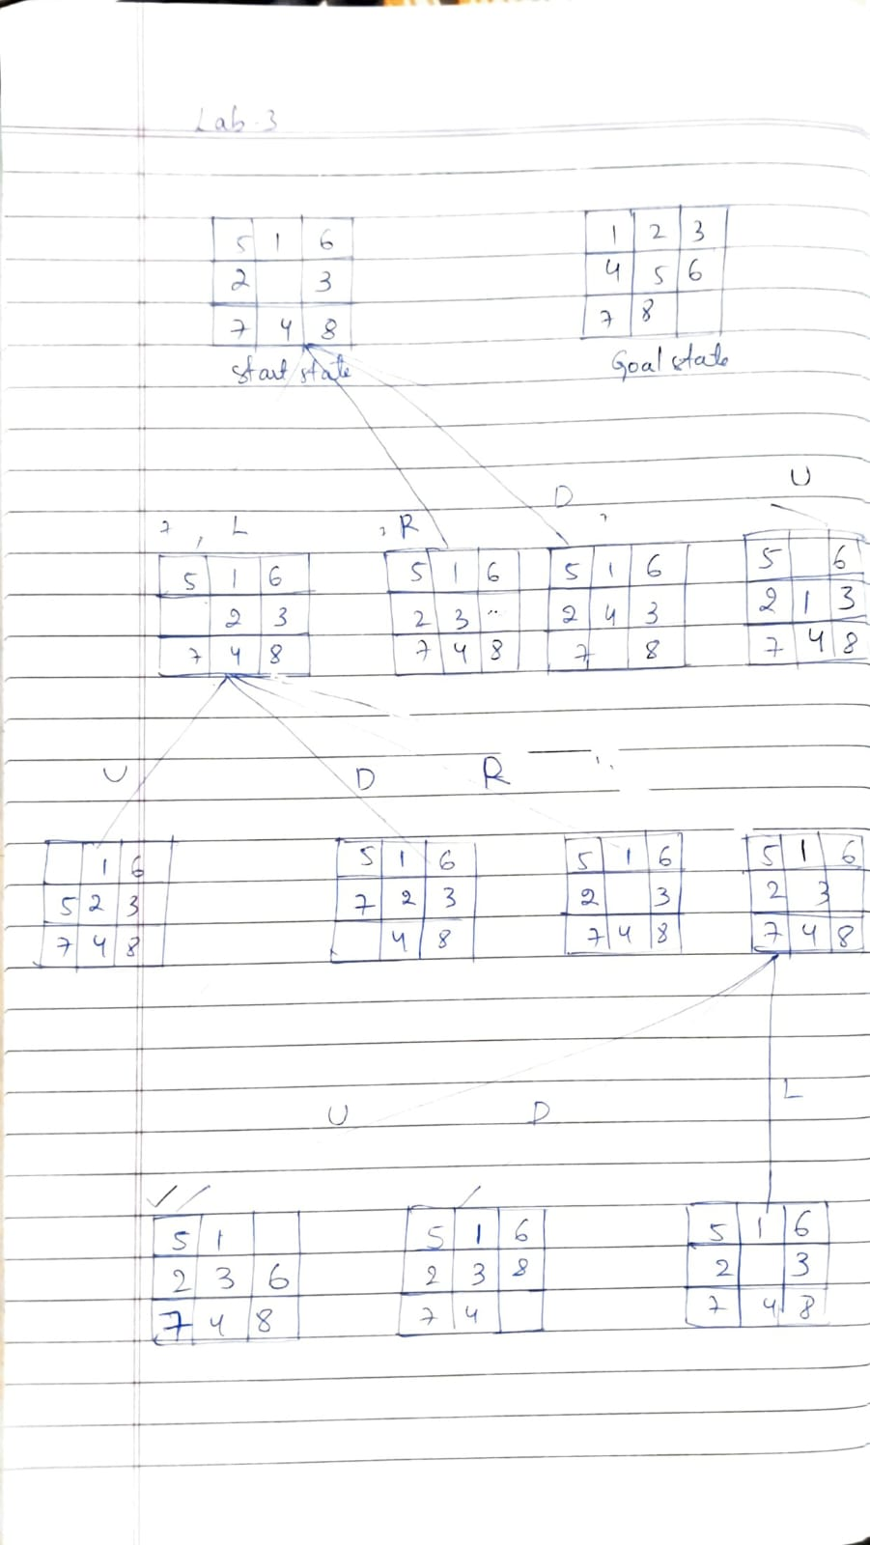
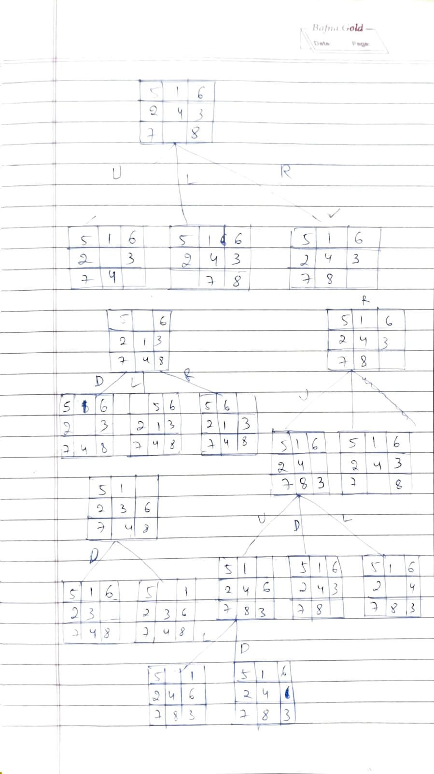
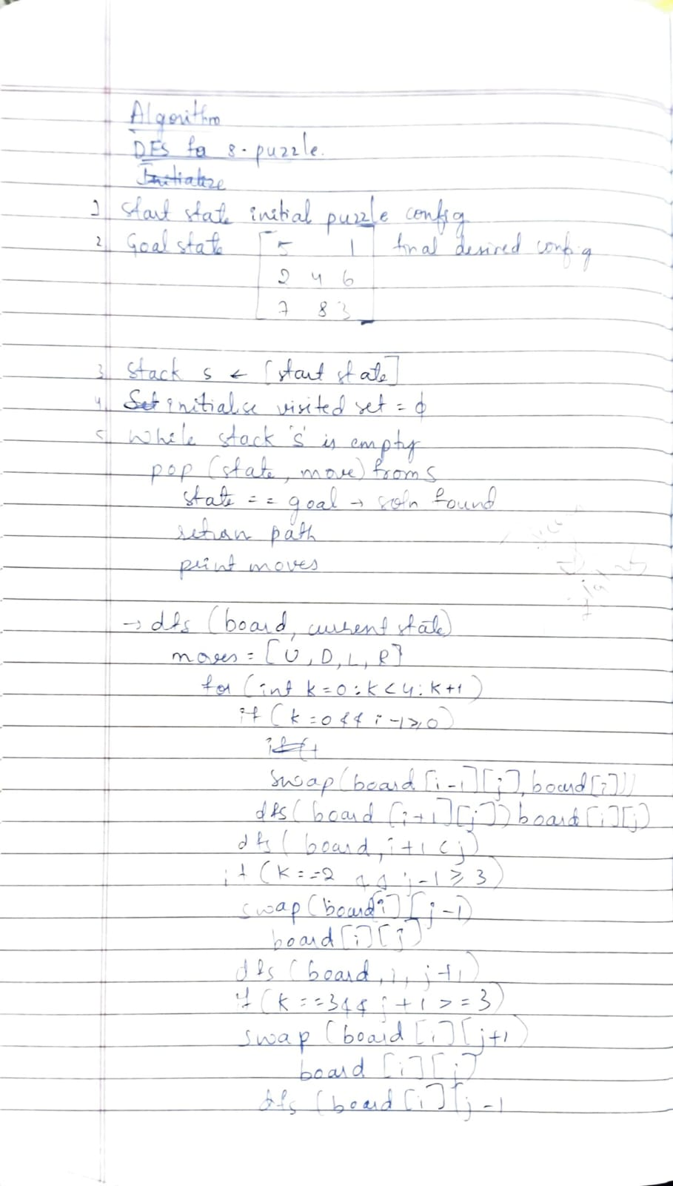
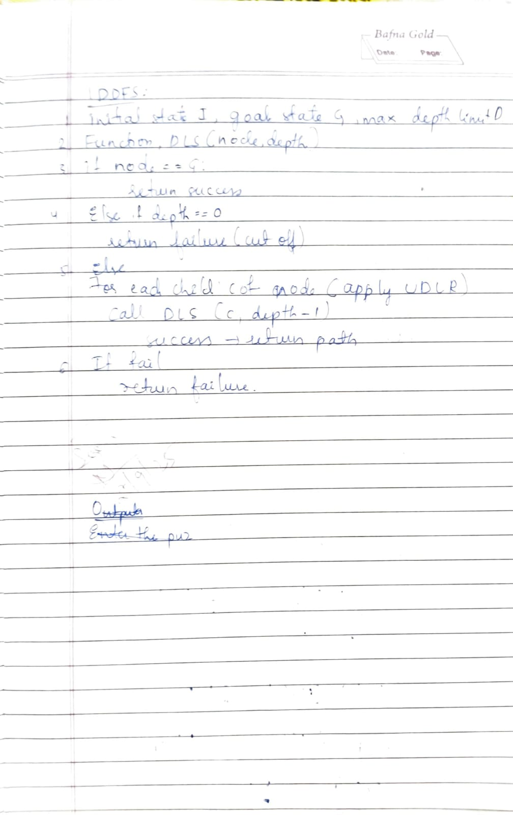
Program 3
Implement A* search algorithm
from heapq import heappush, heappop

GOAL = (1,2,3,4,5,6,7,8,0)
goal_pos = {v:(i//3,i%3) for i,v in enumerate(GOAL)}

def h(state): # Manhattan distance
return sum(abs(i//3-goal_pos[v][0])+abs(i%3-goal_pos[v][1])
for i,v in enumerate(state) if v)

def nbrs(state):
z = state.index(0); r,c = divmod(z,3)
for dr,dc,m in [(-1,0,'Up'),(1,0,'Down'),(0,-1,'Left'),(0,1,'Right')]:
nr,nc = r+dr,c+dc
if 0<=nr<3 and 0<=nc<3:
s=list(state); nz=nr*3+nc
s[z],s[nz]=s[nz],s[z]
yield tuple(s),m

def solvable(s):
arr=[x for x in s if x]
inv=sum(arr[i]>arr[j] for i in range(len(arr)) for j in range(i+1,len(arr)))
return inv%2==0

def astar(start):
if not solvable(start): return None
open=[(h(start),start)]; g={start:0}; came={}
while open:
_,cur=heappop(open)
if cur==GOAL:
moves=[]
while cur in came: cur,m=came[cur]; moves.append(m)
return moves[::-1]
for nxt,m in nbrs(cur):
ng=g[cur]+1
if nxt not in g or ng<g[nxt]:
g[nxt]=ng; heappush(open,(ng+h(nxt),nxt)); came[nxt]=(cur,m)

def show(s):
for i in range(0,9,3): print(*(x or '_' for x in s[i:i+3]))
print()

if __name__=="__main__":
print("Enter the puzzle as 9 numbers (use 0 for blank), e.g.: 1 2 3 4 0 6 7 5 8")
nums = list(map(int, input("Input: ").split()))
start = tuple(nums)

print("\nStart:"); show(start); print("Goal:"); show(GOAL)
sol=astar(start)
if not sol:
print("Not solvable!")
else:
print("Solved in",len(sol),"moves:",' -> '.join(sol))
state=start; show(state)
for m in sol:
for n,mv in nbrs(state):
if mv==m: state=n; break
print(m); show(state)
Manhattan_distance
Implement A* search algorithm
import heapq

# Moves: up, down, left, right
moves = [(-1, 0), (1, 0), (0, -1), (0, 1)]

def manhattan_distance(board, goal):
"""Calculate total Manhattan distance of tiles from their goal positions."""
distance = 0
for i in range(3):
for j in range(3):
tile = board[i][j]
if tile != 0:
# Find goal position of this tile
for gi in range(3):
for gj in range(3):
if goal[gi][gj] == tile:
distance += abs(i - gi) + abs(j - gj)
break
return distance

def find_blank(board):
for i in range(3):
for j in range(3):
if board[i][j] == 0:
return i, j

def get_neighbors(board):
neighbors = []
x, y = find_blank(board)
for dx, dy in moves:
nx, ny = x + dx, y + dy
if 0 <= nx < 3 and 0 <= ny < 3:
new_board = [row[:] for row in board]
new_board[x][y], new_board[nx][ny] = new_board[nx][ny], new_board[x][y]
neighbors.append(new_board)
return neighbors

def board_to_tuple(board):
return tuple(tuple(row) for row in board)

def a_star_search(start, goal):
open_list = []
start_h = manhattan_distance(start, goal)
heapq.heappush(open_list, (start_h, 0, start, [start]))
closed_set = set()

while open_list:
f, g, current, path = heapq.heappop(open_list)

if current == goal:
return path

closed_set.add(board_to_tuple(current))

for neighbor in get_neighbors(current):
neighbor_tuple = board_to_tuple(neighbor)
if neighbor_tuple in closed_set:
continue
g_new = g + 1
h_new = manhattan_distance(neighbor, goal)
f_new = g_new + h_new
heapq.heappush(open_list, (f_new, g_new, neighbor, path + [neighbor]))

return None

def get_user_input(prompt_text):
print(f"\nEnter the {prompt_text} (use 0 for the blank tile).")
board = []
nums_seen = set()
for i in range(3):
while True:
try:
row = input(f"Enter row {i + 1} (e.g., 1 2 3): ").strip().split()
if len(row) != 3:
raise ValueError
row_int = [int(x) for x in row]
for n in row_int:
if n < 0 or n > 8 or n in nums_seen:
raise ValueError
nums_seen.add(n)
board.append(row_int)
break
except ValueError:
print("Invalid input! Enter three unique integers from 0 to 8, no duplicates.")
return board

def print_board(board):
for row in board:
print(' '.join(str(x) for x in row))

# Direct execution

initial_state = get_user_input("initial state")
goal_state = get_user_input("goal state")

print("\nSolving the puzzle using A* search with Manhattan Distance heuristic...\n")
solution = a_star_search(initial_state, goal_state)

if solution:
print(f"Solution found in {len(solution) - 1} moves:\n")
for step, state in enumerate(solution):
print(f"Step {step}:")
print_board(state)
print()
else:
print("No solution found.")
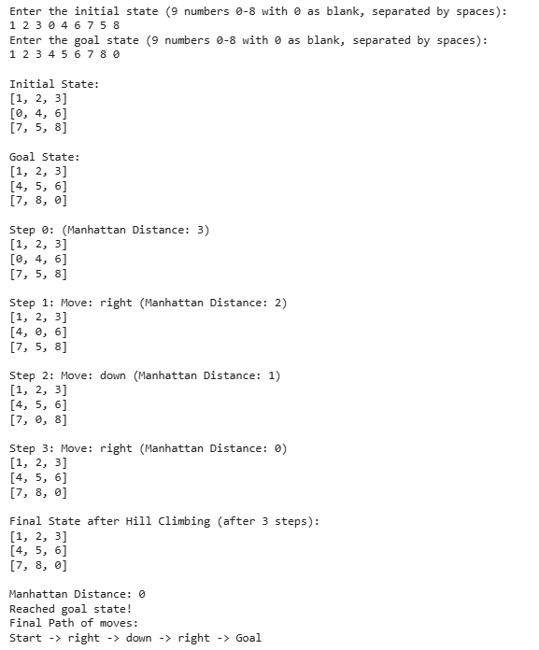
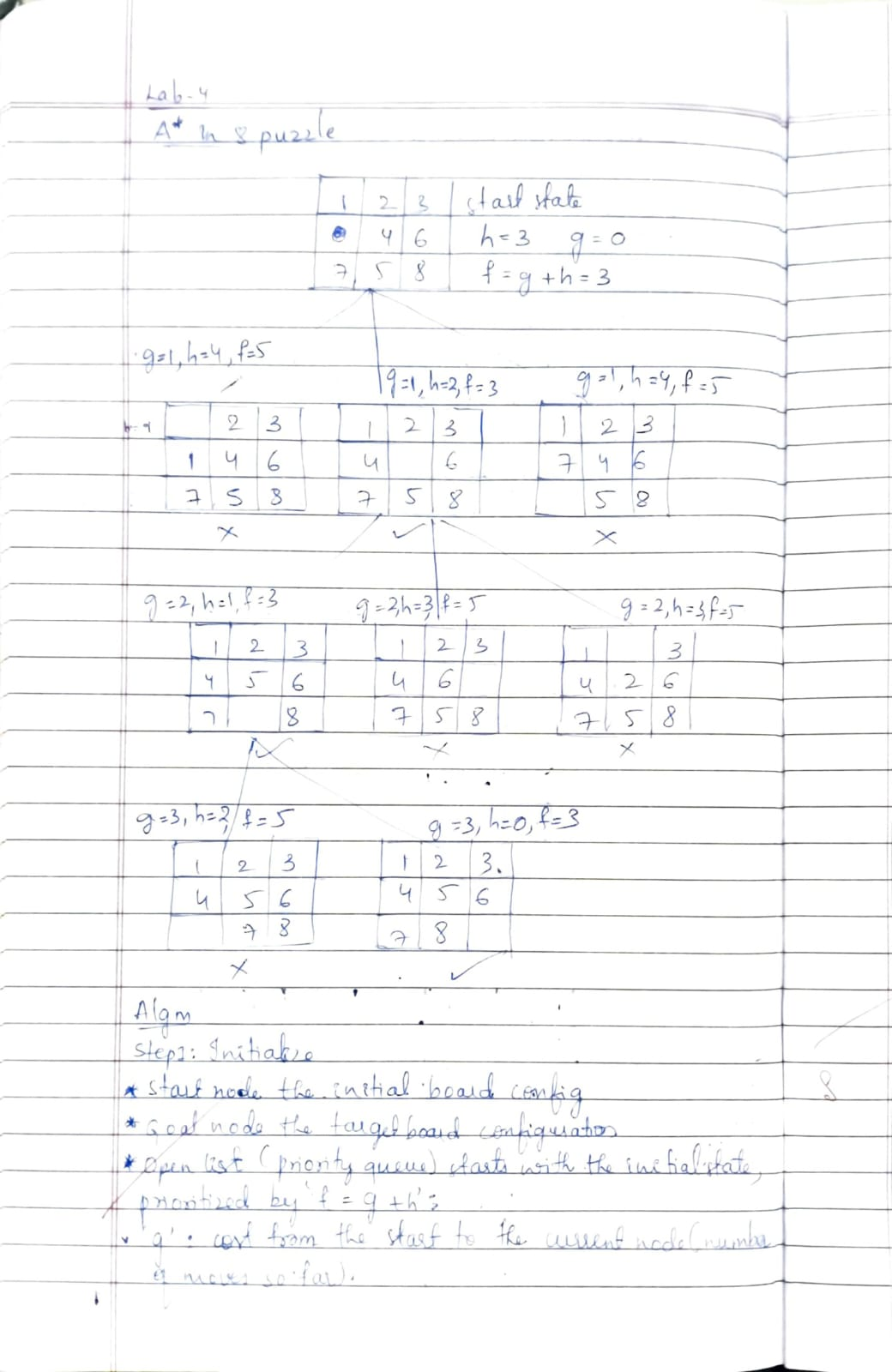
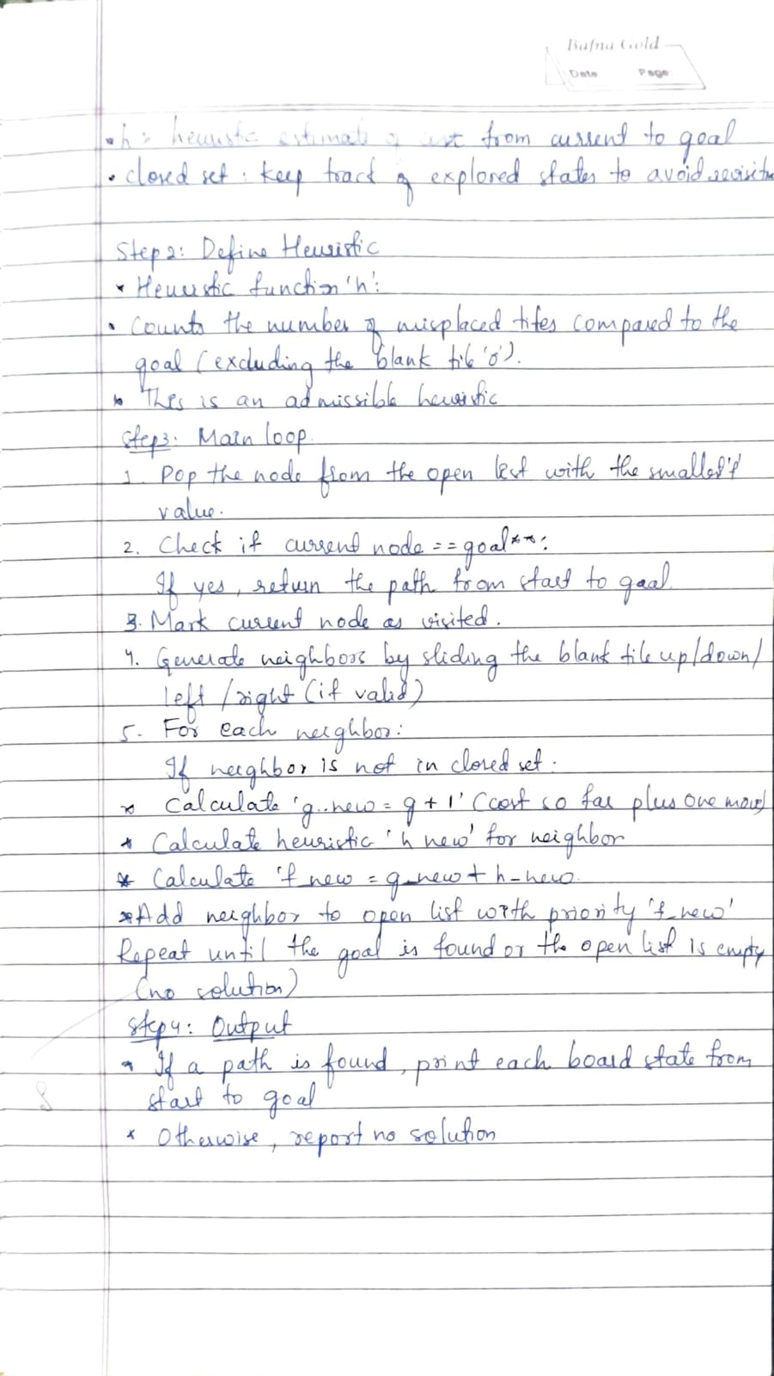
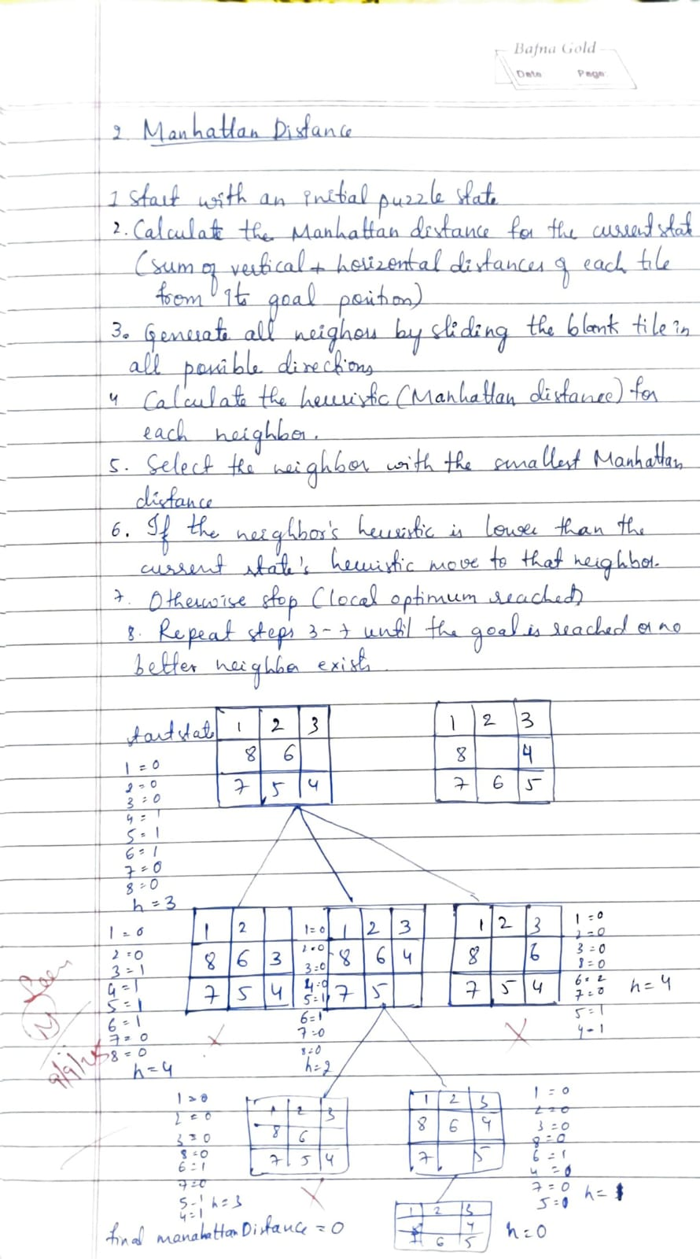
Misplaced_tiles
def read_state(prompt):
print(prompt)
numbers = input().strip().split()
if len(numbers) != 9 or not all(n.isdigit() for n in numbers):
print("Enter exactly 9 numbers separated by spaces.")
return read_state(prompt)
return [list(map(int, numbers[i*3:(i+1)*3])) for i in range(3)]

def misplaced_tiles(state, goal):
return sum(
1 for i in range(3) for j in range(3)
if state[i][j] != 0 and state[i][j] != goal[i][j]
)

def find_zero(state):
for i in range(3):
for j in range(3):
if state[i][j] == 0:
return i, j

def get_neighbors(state):
neighbors = []
x, y = find_zero(state)
moves = [(-1,0), (1,0), (0,-1), (0,1)]
for dx, dy in moves:
nx, ny = x + dx, y + dy
if 0 <= nx < 3 and 0 <= ny < 3:
new_state = [row[:] for row in state]
new_state[x][y], new_state[nx][ny] = new_state[nx][ny], new_state[x][y]
neighbors.append(new_state)
return neighbors

def state_equal(s1, s2):
return all(s1[i][j] == s2[i][j] for i in range(3) for j in range(3))

def solve(initial, goal, max_steps=30):
current = initial
steps = 0
visited = []

print("Starting state:")
for row in current:
print(row)

while not state_equal(current, goal) and steps < max_steps:
visited.append(current)
neighbors = get_neighbors(current)
best = None
lowest_h = float('inf')
for neighbor in neighbors:
if any(state_equal(neighbor, v) for v in visited):
continue
h = misplaced_tiles(neighbor, goal)
if h < lowest_h:
lowest_h = h
best = neighbor
if best is None:
print("No more moves or stuck. Aborting.")
return
current = best
steps += 1
print(f"\nStep {steps}, Misplaced tiles: {lowest_h}")
for row in current:
print(row)

if state_equal(current, goal):
print("\nSolved in", steps, "steps!")
else:
print("\nMax steps reached or stuck, not solved.")

initial_state = read_state("Enter the initial state (use 0 for blank):")
goal_state = read_state("Enter the goal state:")

solve(initial_state, goal_state)
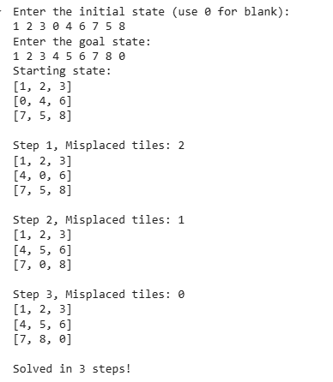
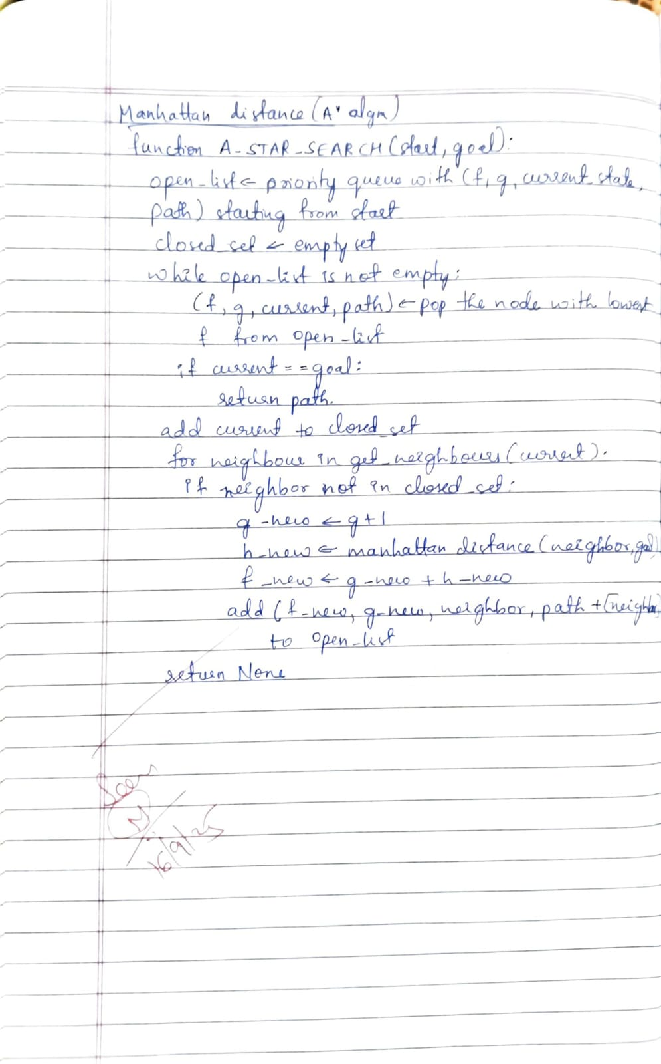
Program 4
Implement Hill Climbing search algorithm to solve N-Queens problem
import heapq

moves = [(-1, 0), (1, 0), (0, -1), (0, 1)]

def manhattan_distance(board, goal):
distance = 0
for i in range(3):
for j in range(3):
tile = board[i][j]
if tile != 0:

for gi in range(3):
for gj in range(3):
if goal[gi][gj] == tile:
distance += abs(i - gi) + abs(j - gj)
break
return distance

def find_blank(board):
for i in range(3):
for j in range(3):
if board[i][j] == 0:
return i, j

def get_neighbors(board):
neighbors = []
x, y = find_blank(board)
for dx, dy in moves:
nx, ny = x + dx, y + dy
if 0 <= nx < 3 and 0 <= ny < 3:
new_board = [row[:] for row in board]
new_board[x][y], new_board[nx][ny] = new_board[nx][ny], new_board[x][y]
neighbors.append(new_board)
return neighbors

def board_to_tuple(board):
return tuple(tuple(row) for row in board)

def a_star_search(start, goal):
open_list = []
start_h = manhattan_distance(start, goal)
heapq.heappush(open_list, (start_h, 0, start, [start]))
closed_set = set()

while open_list:
f, g, current, path = heapq.heappop(open_list)

if current == goal:
return path

closed_set.add(board_to_tuple(current))

for neighbor in get_neighbors(current):
neighbor_tuple = board_to_tuple(neighbor)
if neighbor_tuple in closed_set:
continue
g_new = g + 1
h_new = manhattan_distance(neighbor, goal)
f_new = g_new + h_new
heapq.heappush(open_list, (f_new, g_new, neighbor, path + [neighbor]))

return None

def get_user_input(prompt_text):
print(f"\nEnter the {prompt_text} (use 0 for the blank tile).")
board = []
nums_seen = set()
for i in range(3):
while True:
try:
row = input(f"Enter row {i + 1} (e.g., 1 2 3): ").strip().split()
if len(row) != 3:
raise ValueError
row_int = [int(x) for x in row]
for n in row_int:
if n < 0 or n > 8 or n in nums_seen:
raise ValueError
nums_seen.add(n)
board.append(row_int)
break
except ValueError:
print("Invalid input! Enter three unique integers from 0 to 8, no duplicates.")
return board

def print_board(board):
for row in board:
print(' '.join(str(x) for x in row))

initial_state = get_user_input("initial state")
goal_state = get_user_input("goal state")

print("\nSolving the puzzle using A* search with Manhattan Distance heuristic...\n")
solution = a_star_search(initial_state, goal_state)

if solution:
print(f"Solution found in {len(solution) - 1} moves:\n")
for step, state in enumerate(solution):
print(f"Step {step}:")
print_board(state)
print()
else:
print("No solution found.")
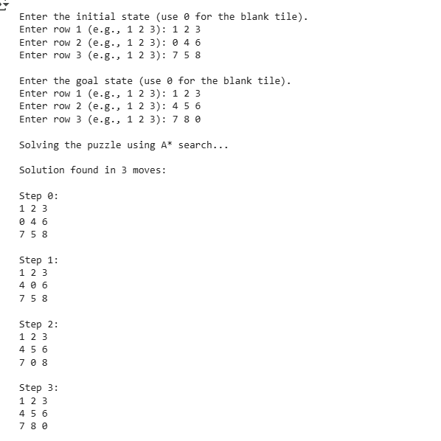
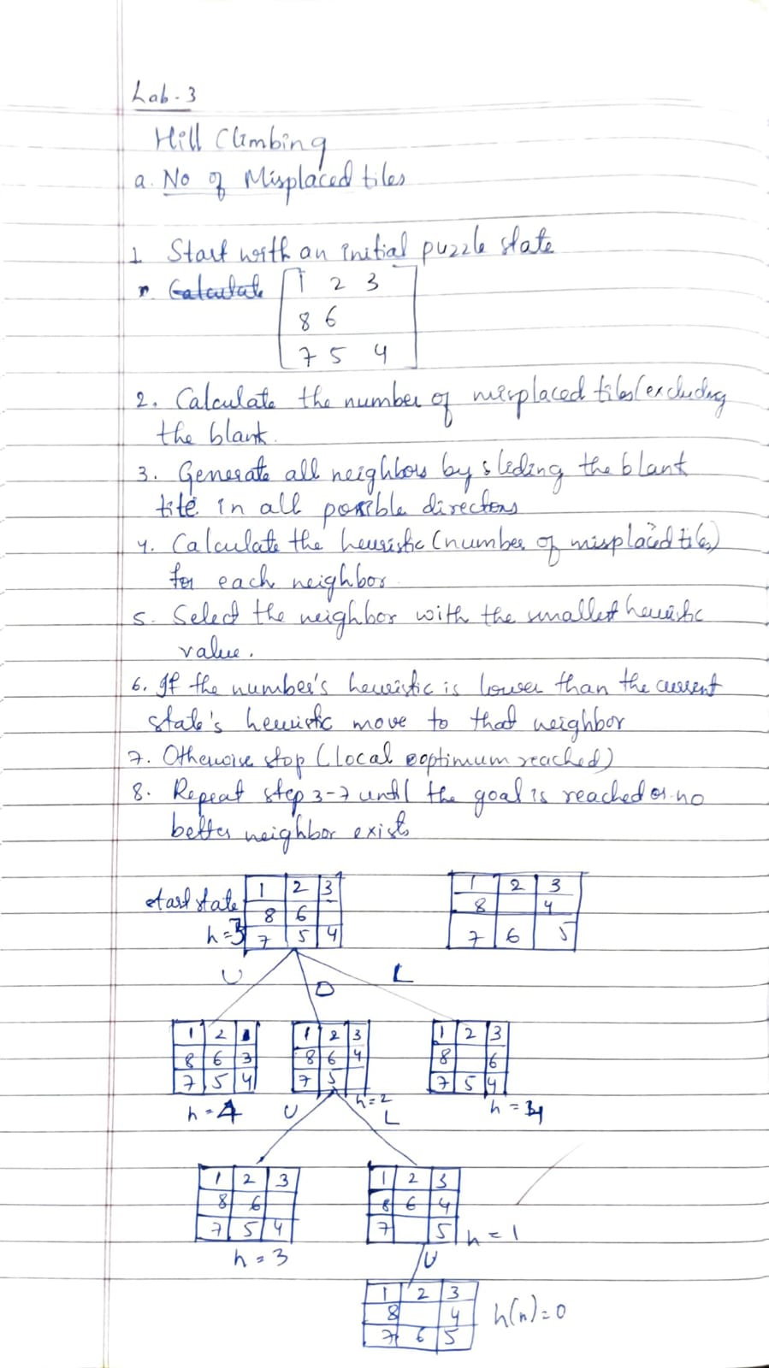

Program 6
Create a knowledge base using propositional logic and show that the given query entails the knowledge base or not.
import re
from itertools import product

def normalize_implications(expr):
expr = re.sub(r'([A-Za-z0-9_() ]+)\s*<->\s*([A-Za-z0-9_() ]+)',
r'((\1) == (\2))', expr)
expr = re.sub(r'([A-Za-z0-9_() ]+)\s*->\s*([A-Za-z0-9_() ]+)',
r'(((not (\1)) or (\2)))', expr)
return expr

def evaluate(expr, model):
expr = expr.replace("~", " not ")
expr = expr.replace("&", " and ")
expr = expr.replace("|", " or ")
expr = normalize_implications(expr)
for symbol in sorted(model.keys(), key=len, reverse=True):
expr = re.sub(r'\b' + re.escape(symbol) + r'\b', str(model[symbol]), expr)
return eval(expr)

def all_symbols(kb_sentences, query):
text = " ".join(kb_sentences + [query])
syms = set(re.findall(r'\b[A-Za-z][A-Za-z0-9_]*\b', text))
return sorted(syms)

def truth_table_entailment(kb_sentences, query):
symbols = all_symbols(kb_sentences, query)
print("\nPropositional Symbols:", symbols)
models = list(product([True, False], repeat=len(symbols)))
header = symbols + ["KB True?", "Query"]
print("\n" + " | ".join(f"{h:^8}" for h in header))
print("-" * (11 * len(header)))

entails = True
counterexample = None

for vals in models:
model = dict(zip(symbols, vals))
kb_vals = [evaluate(s, model) for s in kb_sentences]
kb_true = all(kb_vals)
query_val = evaluate(query, model)
row = [str(model[s]) for s in symbols] + [str(kb_true), str(query_val)]
print(" | ".join(f"{c:^8}" for c in row))

if kb_true and not query_val:
entails = False
counterexample = model

if entails:
print("\n The query IS entailed by the Knowledge Base (KB ⊨ Query)")
else:
print("\n The query is NOT entailed by the Knowledge Base (KB ⊭ Query)")
print("Counterexample model (KB true but Query false):", counterexample)

print("=== PROPOSITIONAL LOGIC ENTAILMENT CHECKER ===")
n = int(input("Enter number of sentences in Knowledge Base (KB): "))

kb = []
for i in range(n):
kb.append(input(f"Enter sentence {i+1}: "))

query = input("Enter the Query: ")

print("\nKnowledge Base (KB):", kb)
print("Query:", query)

truth_table_entailment(kb, query)
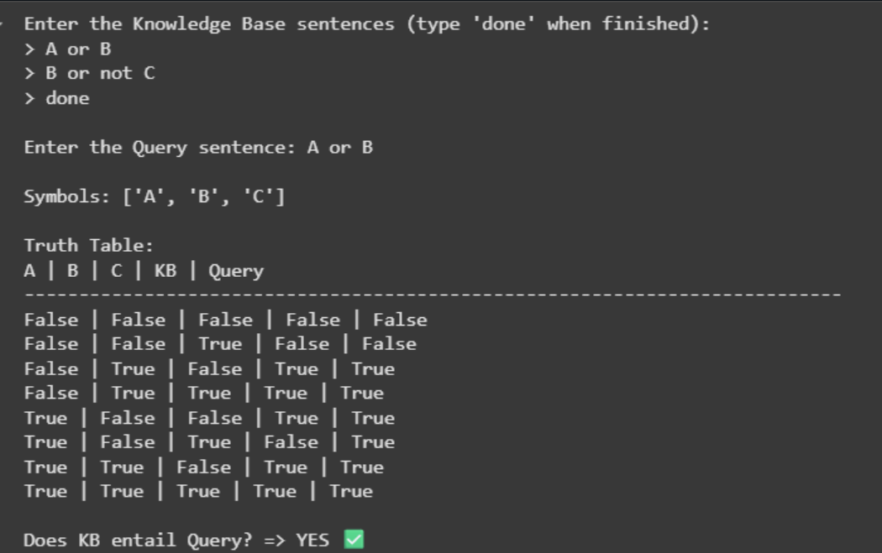
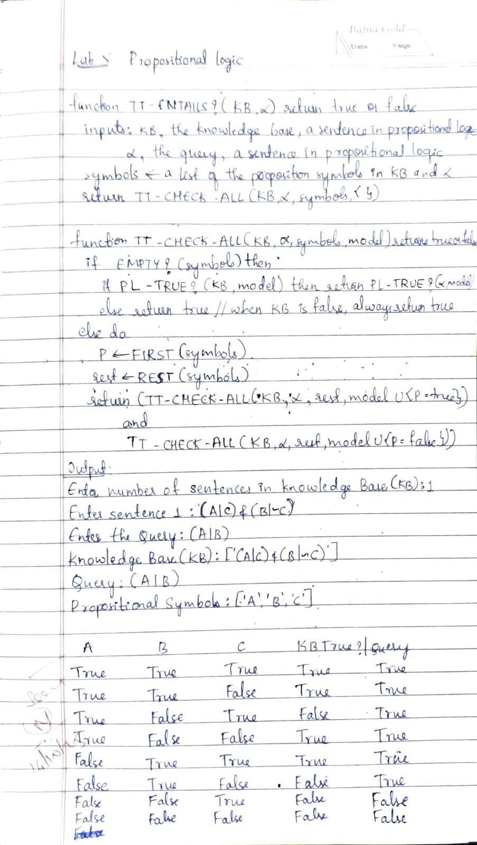

Program 7
Implement unification in first order logic
#unification

def is_variable(x):
return isinstance(x, str) and x.islower()

def occur_check(var, expr):
if var == expr:
return True
if isinstance(expr, list):
return any(occur_check(var, e) for e in expr)
return False

def unify(x, y, subst=None):
if subst is None:
subst = {}
if x == y:
return subst
elif is_variable(x):
if occur_check(x, y):
print(f"Failure: occur-check failed for {x} in {y}")
return None
subst[x] = y
return subst
elif is_variable(y):
if occur_check(y, x):
print(f"Failure: occur-check failed for {y} in {x}")
return None
subst[y] = x
return subst
elif isinstance(x, list) and isinstance(y, list):
if len(x) != len(y):
print(f"Failure: different arity - {len(x)} vs {len(y)}")
return None
if x[0] != y[0]:
print(f"Failure: different function symbols - {x[0]} vs {y[0]}")
return None
for xi, yi in zip(x, y):
result = unify(xi, yi, subst)
if result is None:
return None
subst = result
return subst
else:
print(f"Failure: cannot unify {x} and {y}")
return None

expr1 = ['f', 'x', 'b']
expr2 = ['f', 'a', 'y']
print("Expression 1:", expr1)
print("Expression 2:", expr2)
result = unify(expr1, expr2)
if result is not None:
print("Unification Result:", result)
else:
print("Unification Failure")

expr3 = ['f', 'x', 'b']
expr4 = ['g', 'a', 'y']
print("\nExpression 1:", expr3)
print("Expression 2:", expr4)
result2 = unify(expr3, expr4)
if result2 is not None:
print("Unification Result:", result2)
else:
print("Unification Failure")
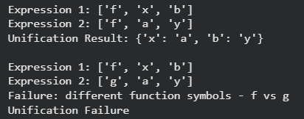
Program 8
Create a knowledge base consisting of first order logic statements and prove the given query using forward reasoning.
def forward_chaining_criminal(facts, rule, query):
derived = set(facts)
premises, conclusion = rule

print("\n--- Starting Forward Chaining ---")

while True:
new_inference = False

inferred = unify_and_substitute(premises, derived, conclusion, {})

if inferred and inferred not in derived:
print(f"Applying Rule: { ' ^ '.join(premises)} => {conclusion}")
print(f"Inferred: {inferred}")
derived.add(inferred)
new_inference = True

if inferred == query:
return True, derived

if not new_inference:
break

return (query in derived), derived

facts_criminal = {
"American(Robert)",
"Weapons(T1)",
"Sells(Robert, T1, A)",
"Hostile(A)"
}

criminal_rule_premises = [
"American(p)",
"Weapons(q)",
"Sells(p, q, r)",
"Hostile(r)"
]
criminal_rule_conclusion = "Criminal(p)"

rules_criminal = (criminal_rule_premises, criminal_rule_conclusion)

query_criminal = "Criminal(Robert)"

result_criminal, derived_facts_criminal = forward_chaining_criminal(facts_criminal, rules_criminal, query_criminal)

print("\n--- Final Facts Derived ---")
for f in derived_facts_criminal:
print(f)

print("\nQuery:", query_criminal)
print("Result:", "TRUE (Robert is a Criminal)" if result_criminal else "FALSE (Not provable)")
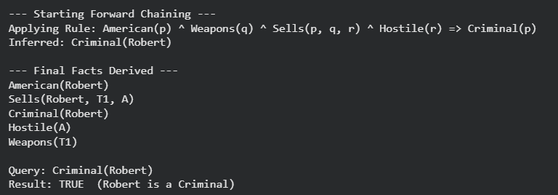
Program 9
Create a knowledge base consisting of first order logic statements and prove the given query using Resolution
def is_variable(x):
return isinstance(x, str) and len(x) > 0 and x[0].islower()

def substitute(theta, clause):
new_clause = []
for pred in clause:
name, terms = pred[0], pred[1]
new_terms = []
for t in terms:

new_terms.append(theta.get(t, t))
new_clause.append((name, new_terms))
return new_clause

def unify(x, y, theta=None):
if theta is None:
return None
if x == y:
return theta
if is_variable(x):
return unify_var(x, y, theta)
if is_variable(y):
return unify_var(y, x, theta)

if isinstance(x, list) and isinstance(y, list) and len(x) == len(y):
for xi, yi in zip(x, y):
theta = unify(xi, yi, theta)
if theta is None:
return None
return theta
return None

def unify_var(var, x, theta):
if var in theta:
return unify(theta[var], x, theta)
if x in theta:
return unify(var, theta[x], theta)

new_theta = theta.copy()
new_theta[var] = x
return new_theta

def resolve(ci, cj):
resolvents = []
for pi in ci:
for pj in cj:
name_i = pi[0].lstrip("¬")
name_j = pj[0].lstrip("¬")

if name_i == name_j and (pi[0].startswith("¬") != pj[0].startswith("¬")):
theta = unify(pi[1], pj[1], {})
if theta is not None:
new_ci = substitute(theta, [x for x in ci if x != pi])
new_cj = substitute(theta, [x for x in cj if x != pj])
combined = []
for lit in (new_ci + new_cj):
if lit not in combined:
combined.append(lit)
resolvents.append(combined)
return resolvents

def resolution(kb, query):
neg_query = [("¬" + query[0], query[1])]
clauses = [list(c) for c in kb] + [neg_query]

new = []
while True:
n = len(clauses)
pairs = [(clauses[i], clauses[j]) for i in range(n) for j in range(i+1, n)]
for (ci, cj) in pairs:
for r in resolve(ci, cj):
if r == []:
return True
if r not in new and r not in clauses:
new.append(r)
if not new:
return False
added_any = False
for c in new:
if c not in clauses:
clauses.append(c)
added_any = True
if not added_any:
return False
new = []

KB = [
[("¬Food", ["x"]), ("Likes", ["John", "x"])],

[("Food", ["Apple"])],
[("Food", ["Vegetable"])],

[("¬Eats", ["a", "b"]), ("¬NotKilled", ["a"]), ("Food", ["b"])],

[("Eats", ["Anil", "Peanuts"])],
[("Alive", ["Anil"])],

[("¬Eats", ["Anil", "x"]), ("Eats", ["Harry", "x"])],

[("¬Alive", ["x"]), ("NotKilled", ["x"])],

[("¬NotKilled", ["x"]), ("Alive", ["x"])]
]

query = ("Likes", ["John", "Peanuts"])

print("Proving:", query)
res = resolution(KB, query)
print("Proved?" , res)
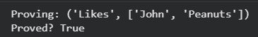
Program 10
Implement Alpha-Beta Pruning.
tree = {
'A': 10, 'B': 11, 'C': 9, 'D': 12,
'E': 14, 'F': 15, 'G': 13, 'H': 14,
'I': 5, 'J': 2, 'K': 4, 'L': 1,
'M': 3, 'N': 22, 'O': 20, 'P': 21
}

tree_structure = [
['A', 'B', 'C', 'D'],
['E', 'F', 'G', 'H'],
['I', 'J', 'K', 'L'],
['M', 'N', 'O', 'P']
]

pruned_nodes = []

def alpha_beta_min(values, alpha, beta):
"""MIN level"""
min_val = float('inf')
for name in values:
val = tree[name]
print(f" MIN checks {name}={val}, α={alpha}, β={beta}")
if val < min_val:
min_val = val
if min_val <= alpha:
# prune remaining nodes
pruned_nodes.extend(values[values.index(name)+1:])
print(f"Pruning at MIN node after {name}: {values[values.index(name)+1:]}")
break
beta = min(beta, min_val)
print(f" → MIN returns {min_val}")
return min_val

def alpha_beta_max(structure, alpha, beta):
"""MAX level"""
max_val = float('-inf')
best_branch = None
for group in structure:
print(f"\nExploring branch: {group}")
val = alpha_beta_min(group, alpha, beta)
if val > max_val:
max_val = val
best_branch = group
if max_val >= beta:
remaining = structure[structure.index(group)+1:]
for g in remaining:
pruned_nodes.extend(g)
print(f"Pruning at MAX after {group}")
break
alpha = max(alpha, max_val)
print(f"MAX updated α={alpha}, β={beta}")
print(f"\n→ MAX returns {max_val}")
return max_val, best_branch

root_value, path = alpha_beta_max(tree_structure, float('-inf'), float('inf'))

print("\n===========================")
print("Root Node Value (MAX):", root_value)
print("Best Path (Branch):", path)
print("Pruned Nodes:", pruned_nodes)
